**Practical 1**:

**Practical 2:**

**Practical 3:**

1. Compile server code and listen:

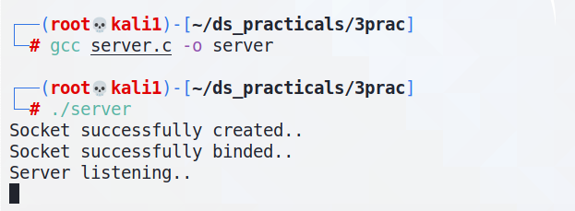

1. Compile client code and send message to server:

1. Server receives client’s message. Also, send a message from server to client:

1. Client receives server’s message:

**Practical 4:**

1. Generate rpc stubs by rpcgen:

1. Compile the code after making changes to transfer_client.c & transfer_server.c:

1. Create a receiver directory and start server:

1. Send a sample file (named file_to_send.txt and contents “Hello world”):

1. Server receives the file:

**Practical 5**:

1. Compile files, create stubs (by rmic) and start rmiregistry at port 5000:

1. Start server in one tab:

1. Execute client in another tab:

**Practical 6:**

